- Perform basic Image Handling and processing operations on the image.
AIM: To perform basic Image Handling and processing operations on the image.
PROGRAM:
import cv2
import matplotlib.pyplot as plt

image = cv2.imread('/content/Screenshot 2025-04-29 151107.png')
image_rgb = cv2.cvtColor(image, cv2.COLOR_BGR2RGB)
gray_image = cv2.cvtColor(image, cv2.COLOR_BGR2GRAY)

plt.figure(figsize=(10, 5))
plt.subplot(1, 2, 1)
plt.imshow(image_rgb)
plt.title('Original Image')
plt.axis('off')

plt.subplot(1, 2, 2)
plt.imshow(gray_image, cmap='gray')
plt.title('Grayscale Image')
plt.axis('off')

plt.tight_layout()
plt.show()

INPUT:
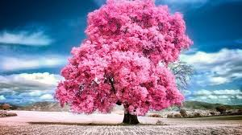
OUTPUT:
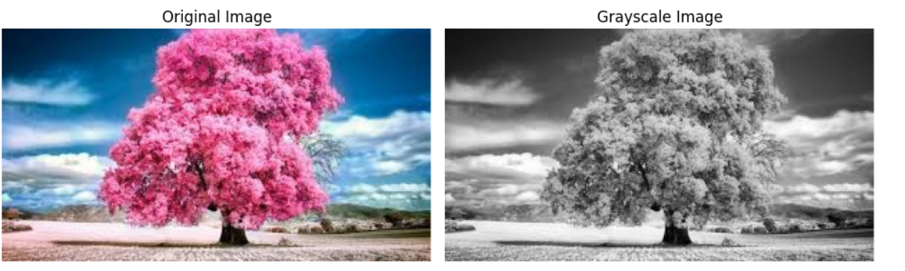

- Perform basic Image Handling and processing operations on the image.
AIM: To perform basic Image Handling and processing operations on the image.
PROGRAM:
import cv2
import matplotlib.pyplot as plt

image = cv2.imread('/content/Screenshot 2025-04-29 151758.png')
image_rgb = cv2.cvtColor(image, cv2.COLOR_BGR2RGB)
blurred_image = cv2.GaussianBlur(image_rgb, (15, 15), 0)

plt.figure(figsize=(10, 5))
plt.subplot(1, 2, 1)
plt.imshow(image_rgb)
plt.title('Original Image')
plt.axis('off')

plt.subplot(1, 2, 2)
plt.imshow(blurred_image)
plt.title('Blurred Image')
plt.axis('off')

plt.tight_layout()
plt.show()
INPUT:
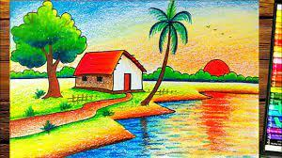

OUTPUT:
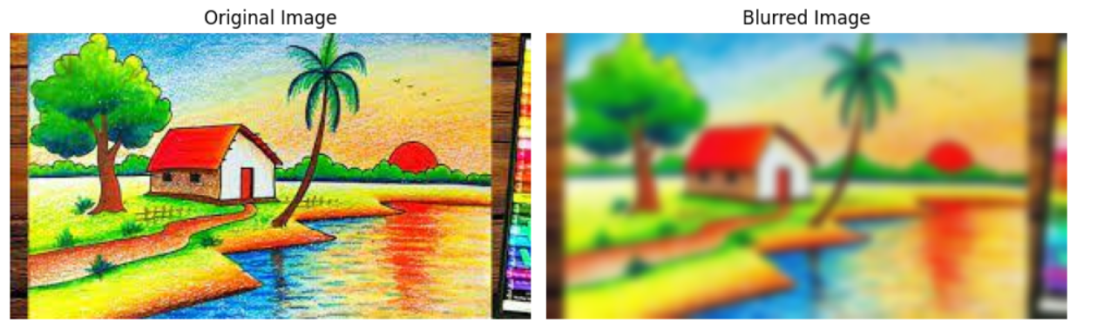

3. Perform basic Image Handling and processing operations on the image.
AIM: To perform basic Image Handling and processing operations on the image.
PROGRAM:
import cv2
import matplotlib.pyplot as plt

image = cv2.imread('/content/Screenshot 2025-04-30 101441.png')
image_rgb = cv2.cvtColor(image, cv2.COLOR_BGR2RGB)
gray_image = cv2.cvtColor(image, cv2.COLOR_BGR2GRAY)
edges = cv2.Canny(gray_image, 100, 200)

plt.figure(figsize=(10, 5))
plt.subplot(1, 2, 1)
plt.imshow(image_rgb)
plt.title('Original Image')
plt.axis('off')

plt.subplot(1, 2, 2)
plt.imshow(edges, cmap='gray')
plt.title('Canny Edge Detection')
plt.axis('off')

plt.tight_layout()
plt.show()

INPUT:
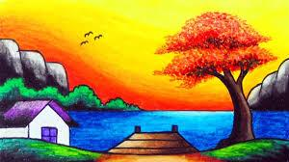
OUTPUT:
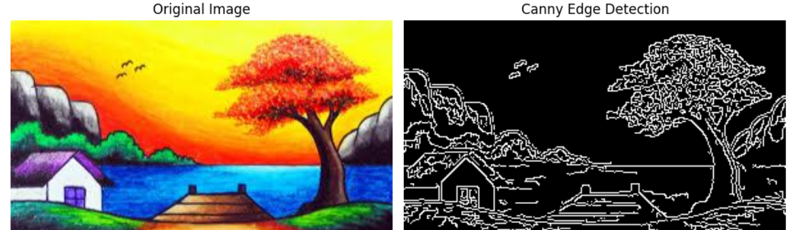

4. Perform basic Image Handling and processing operations on the image.
AIM: To perform basic Image Handling and processing operations on the image.
PROGRAM:
import cv2
import matplotlib.pyplot as plt

image = cv2.imread('/content/Screenshot 2025-04-30 102000.png')
gray = cv2.cvtColor(image, cv2.COLOR_BGR2GRAY)
_, binary = cv2.threshold(gray, 127, 255, cv2.THRESH_BINARY)
kernel = cv2.getStructuringElement(cv2.MORPH_RECT, (5, 5))
dilated = cv2.dilate(binary, kernel, iterations=1)

plt.figure(figsize=(10, 5))
plt.subplot(1, 2, 1)
plt.imshow(binary, cmap='gray')
plt.title('Binary Image')
plt.axis('off')

plt.subplot(1, 2, 2)
plt.imshow(dilated, cmap='gray')
plt.title('Dilated Image')
plt.axis('off')

plt.tight_layout()
plt.show()

INPUT:
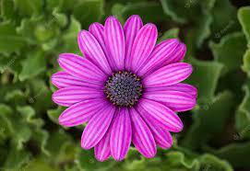
OUTPUT:
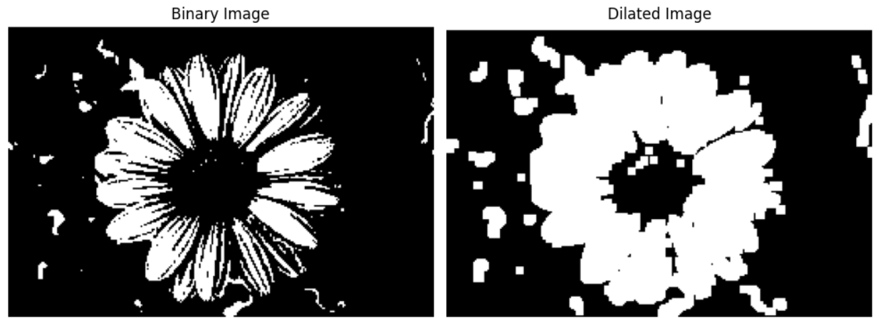

5. Perform basic Image Handling and processing operations on the image.
AIM: To perform basic Image Handling and processing operations on the image.
PROGRAM:
import cv2
import matplotlib.pyplot as plt

image = cv2.imread('/content/Screenshot 2025-04-30 102544.png')
gray = cv2.cvtColor(image, cv2.COLOR_BGR2GRAY)
_, binary = cv2.threshold(gray, 127, 255, cv2.THRESH_BINARY)
kernel = cv2.getStructuringElement(cv2.MORPH_RECT, (5, 5))
eroded = cv2.erode(binary, kernel, iterations=1)

plt.figure(figsize=(10, 5))
plt.subplot(1, 2, 1)
plt.imshow(binary, cmap='gray')
plt.title('Binary Image')
plt.axis('off')

plt.subplot(1, 2, 2)
plt.imshow(eroded, cmap='gray')
plt.title('Eroded Image')
plt.axis('off')

plt.tight_layout()
plt.show()
INPUT:
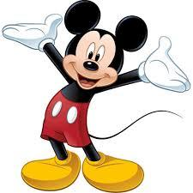

OUTPUT:
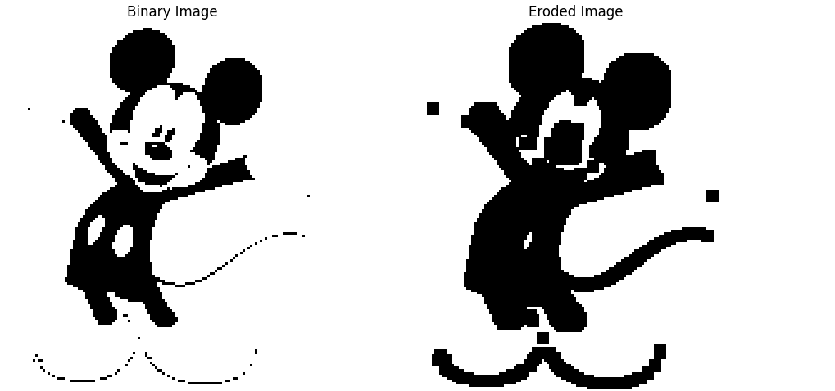

6. Perform basic video processing operations on the captured video.
AIM: To perform basic video processing operations on the captured video.
PROGRAM:
import cv2
from google.colab.patches import cv2_imshow
import time

cap = cv2.VideoCapture('/content/(2) WhatsApp.html') # Replace with your video path

if not cap.isOpened():
print("Error: Cannot open video file")
exit()

speed_mode = 'slow' # Change to 'normal', 'slow', or 'fast'

while cap.isOpened():
ret, frame = cap.read()
if not ret:
break

cv2_imshow(frame)

if speed_mode == 'normal':
time.sleep(1 / 30) # ~30 FPS
elif speed_mode == 'slow':
time.sleep(1 / 10) # Slower (~10 FPS)
elif speed_mode == 'fast':
time.sleep(1 / 60) # Faster (~60 FPS)

cap.release()
INPUT AND OUPUT:
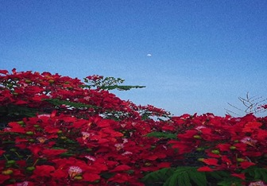

7. Capture video from web Camera and Display the video, in slow motion and in fast motion.
AIM: To capture video from web Camera and Display the video, in slow motion and in fast motion.
PROGRAM:
import cv2
cap = cv2.VideoCapture(0)
speed_mode = input("Enter speed (normal/slow/fast): ").lower()
if speed_mode == 'slow':
delay = 100
elif speed_mode == 'fast':
delay = 10
else:
delay = 30
while True:
ret, frame = cap.read()
if not ret:
break
cv2.imshow('Webcam Video', frame)
if cv2.waitKey(delay) & 0xFF == ord('q'):
break
cap.release()
cv2.destroyAllWindows()
INPUT AND OUTPUT:
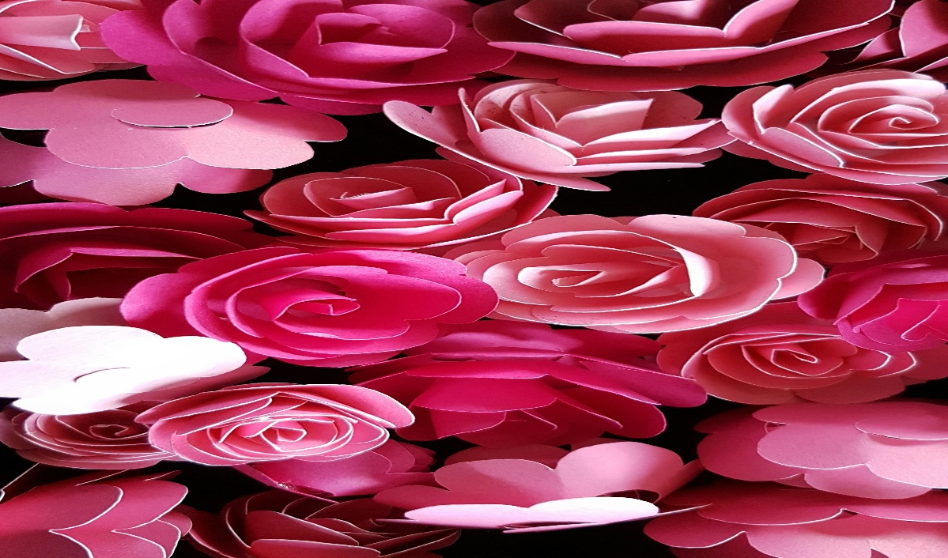
8. Scaling an image to its Bigger and Smaller sizes.
AIM: To scaling an image to its Bigger and Smaller sizes.
PROGRM:
from PIL import Image
from IPython.display import display

image = Image.open("/content/pexels-pixabay-56866.jpg")
original_size = image.size

scale_up = image.resize((original_size[0] * 5, original_size[1] * 6), Image.Resampling.LANCZOS)
scale_down = image.resize((original_size[0] // 3, original_size[1] // 3), Image.Resampling.LANCZOS)

print("Original Image:")
display(image)

print("Upscaled Image:")
display(scale_up)

print("Downscaled Image:")
display(scale_down)
INPUT AND OUTPUT:
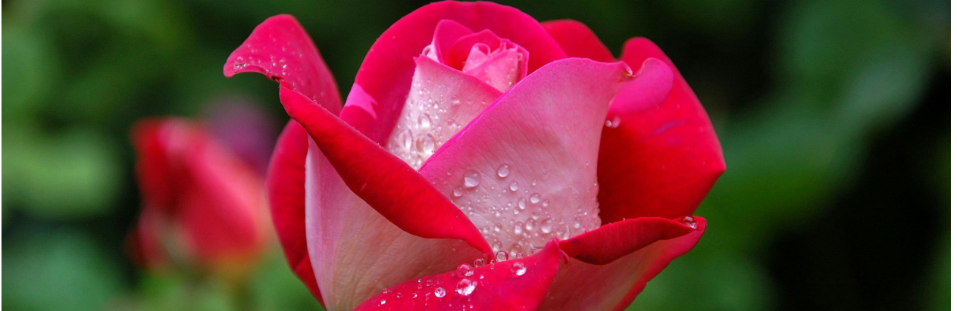
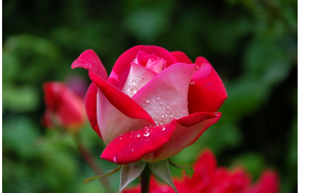

9. Perform Rotation of an image to clockwise and counter clockwise direction.
AIM: To perform Rotation of an image to clockwise and counter clockwise direction.
PROGRAM:
from PIL import Image
import matplotlib.pyplot as plt

image = Image.open("/content/Sample-jpg-image-10mb.jpg")

rotated_clockwise = image.rotate(-90, expand=True)
rotated_counter = image.rotate(90, expand=True)

# Create a figure with 3 subplots side by side
plt.figure(figsize=(15, 5))

# Display Original Image
plt.subplot(1, 3, 1)
plt.imshow(image)
plt.title("Original Image")
plt.axis('off')

# Display Rotated Clockwise (90°)
plt.subplot(1, 3, 2)
plt.imshow(rotated_clockwise)
plt.title("Rotated Clockwise (90°)")
plt.axis('off')

# Display Rotated Counter-Clockwise (90°)
plt.subplot(1, 3, 3)
plt.imshow(rotated_counter)
plt.title("Rotated Counter-Clockwise (90°)")
plt.axis('off')
INPUT AND OUTPUT:
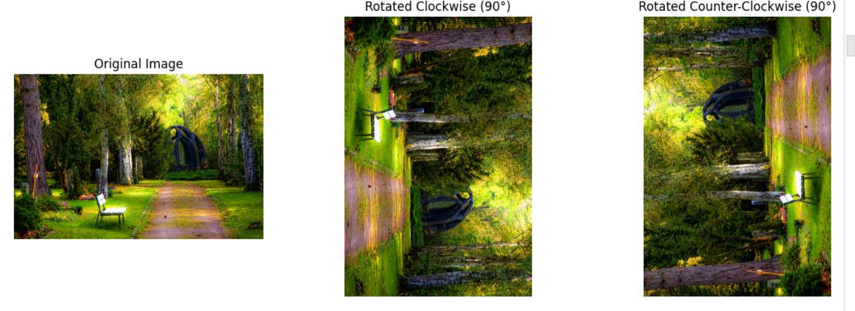

10. Perform moving of an image from one place to another.
AIM: To perform moving of an image from one place to another.
PROGRAM:
pip install opencv-python pillow matplotlib

import cv2
import numpy as np
from google.colab import files
from PIL import Image
import matplotlib.pyplot as plt

uploaded = files.upload()

image_path = list(uploaded.keys())[0]
image = Image.open(image_path)
image_cv = np.array(image)

image_cv = cv2.cvtColor(image_cv, cv2.COLOR_RGB2BGR)

Tx = 100
Ty = 50

translation_matrix = np.float32([[1, 0, Tx], [0, 1, Ty]])

rows, cols, _ = image_cv.shape
translated_image = cv2.warpAffine(image_cv, translation_matrix, (cols, rows))

translated_image_rgb = cv2.cvtColor(translated_image, cv2.COLOR_BGR2RGB)

plt.figure(figsize=(10, 5))

plt.subplot(1, 2, 1)
plt.imshow(image)
plt.title("Original Image")
plt.axis('off')

plt.subplot(1, 2, 2)
plt.imshow(translated_image_rgb)
plt.title("Translated Image")
plt.axis('off')

plt.show()

cv2.imwrite("translated_image.jpg", translated_image)
files.download("translated_image.jpg")

INPUT AND OUTPUT:
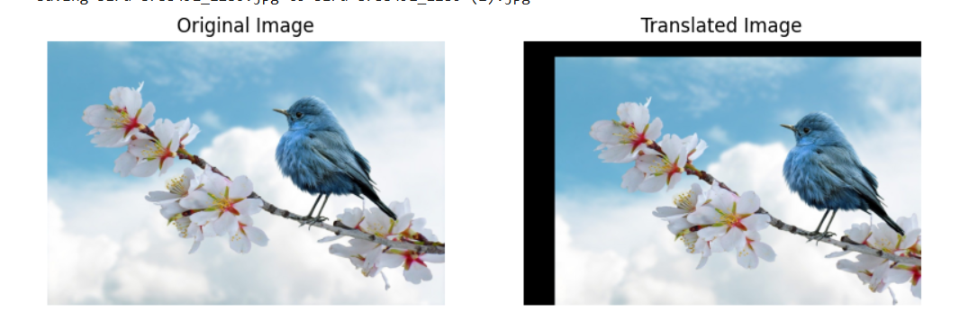
11. Perform Affine Transformation on the image.
AIM: To perform Affine Transformation on the image.
PROGRAM:
from google.colab import files
import matplotlib.pyplot as plt
from PIL import Image

image = Image.open("/content/pexels-pixabay-56866.jpg")

affine_matrix = (1, 0.3, 50, 0.1, 1, 30)

transformed = image.transform(
image.size,
Image.AFFINE,
affine_matrix,
resample=Image.Resampling.BICUBIC
)

plt.figure(figsize=(12, 6))

plt.subplot(1, 2, 1)
plt.imshow(image)
plt.title("Original Image")
plt.axis('off')

plt.subplot(1, 2, 2)
plt.imshow(transformed)
plt.title("Affine Transformed Image")
plt.axis('off')

plt.tight_layout()
plt.show()
INPUT AND OUTPUT:
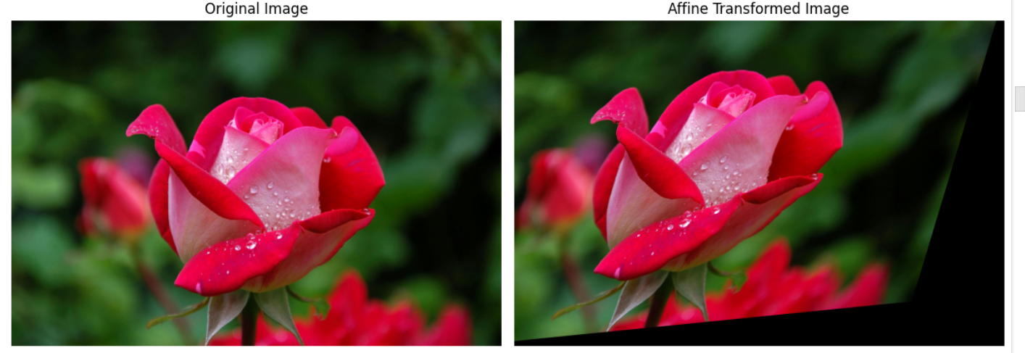
12. Perform Perspective Transformation on the image.
AIM: To perform Perspective Transformation on the image.
PROGRAM:
from google.colab import files
import matplotlib.pyplot as plt
import cv2
import numpy as np

image = cv2.imread("/content/Virat kohli wallpaper 📍.jpeg")
image = cv2.cvtColor(image, cv2.COLOR_BGR2RGB)

height, width = image.shape[:2]

pts1 = np.float32([[50, 50], [width - 50, 50], [50, height - 50], [width - 50, height - 50]])
pts2 = np.float32([[0, 0], [width - 1, 100], [50, height - 50], [width - 1, height - 1]])

matrix = cv2.getPerspectiveTransform(pts1, pts2)
transformed = cv2.warpPerspective(image, matrix, (width, height))

plt.figure(figsize=(12, 6))

plt.subplot(1, 2, 1)
plt.imshow(image)
plt.title("Original Image")
plt.axis('off')

plt.subplot(1, 2, 2)
plt.imshow(transformed)
plt.title("Perspective Transformed Image")
plt.axis('off')

plt.tight_layout()
plt.show()

INPUT AND OUTPUT:
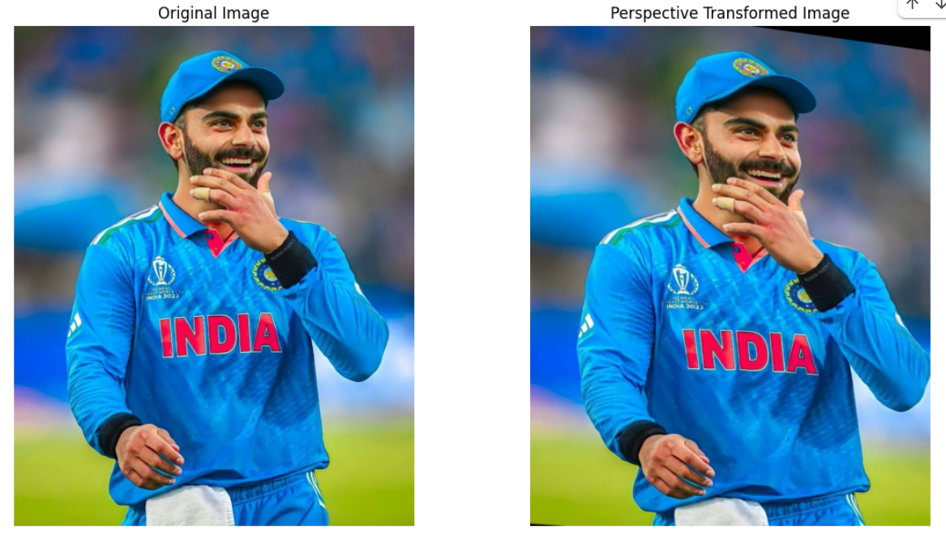
13. Perform Perspective Transformation on the Video.
AIM: To perform Perspective Transformation on the Video.
PROGRAM:
import cv2
import numpy as np
cap = cv2.VideoCapture('video.mp4')
pts1 = np.float32([[50, 50], [300, 50], [50, 300], [300, 300]])
pts2 = np.float32([[0, 0], [300, 0], [0, 300], [300, 300]])
matrix = cv2.getPerspectiveTransform(pts1, pts2)
while cap.isOpened():
ret, frame = cap.read()
if not ret:
break
transformed = cv2.warpPerspective(frame, matrix, (300, 300))
cv2.imshow('Original Video', frame)
cv2.imshow('Perspective Transform', transformed)
if cv2.waitKey(1) & 0xFF == ord('q'):
break
cap.release()
cv2.destroyAllWindows()
INPUT AND OUTPUT:
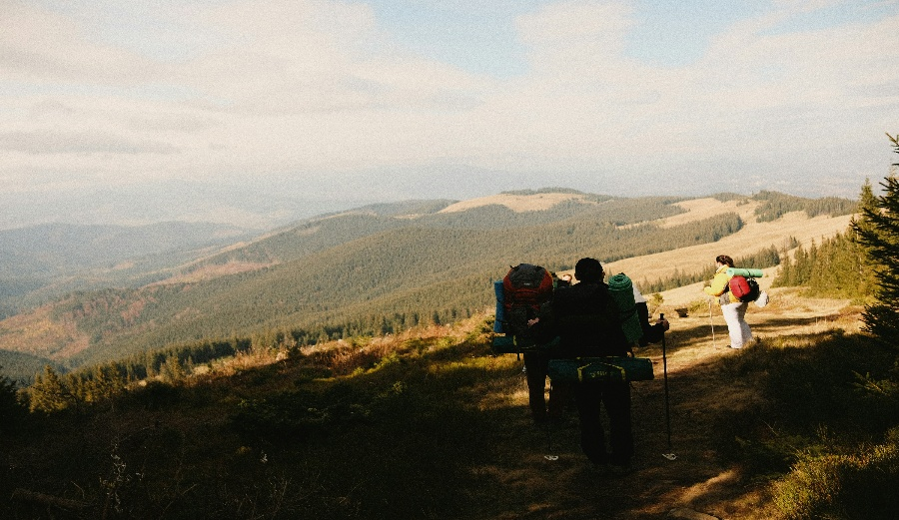

14. Perform transformation using Homography matrix.
AIM: To perform transformation using Homography matrix.
PROGRAM:
import cv2
import numpy as np
import matplotlib.pyplot as plt

# Load image
img = cv2.imread('/content/Virat kohli wallpaper 📍.jpeg') # Replace with your image path
img = cv2.cvtColor(img, cv2.COLOR_BGR2RGB)

# Define source and destination points (in this example, a simple perspective shift)
src_pts = np.float32([[0, 0], [img.shape[1], 0], [img.shape[1], img.shape[0]], [0, img.shape[0]]])
dst_pts = np.float32([[50, 50], [img.shape[1]-50, 50], [img.shape[1]-100, img.shape[0]-50], [100, img.shape[0]-50]])

# Calculate Homography matrix
H, status = cv2.findHomography(src_pts, dst_pts)

# Perform the transformation
transformed_img = cv2.warpPerspective(img, H, (img.shape[1], img.shape[0]))

# Display original and transformed image
plt.subplot(1, 2, 1)
plt.title("Original")
plt.imshow(img)

plt.subplot(1, 2, 2)
plt.title("Transformed")
plt.imshow(transformed_img)

plt.show()

INPUT AND OUTPUT:
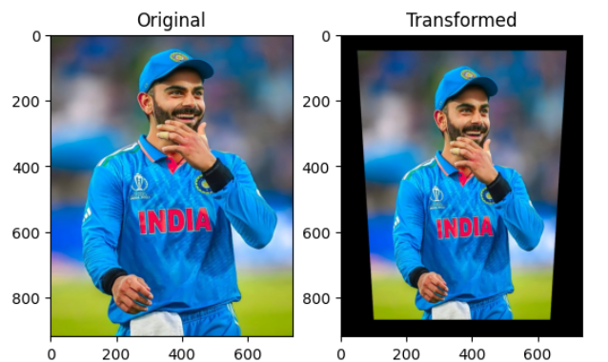
15. Perform transformation using Direct Linear Transformation.
AIM: To perform transformation using Direct Linear Transformation.
PROGRAM:
import numpy as np
import cv2
import matplotlib.pyplot as plt
from PIL import Image

image_path = '/content/pexels-chetanvlad-1595655.jpg'
image = Image.open(image_path).convert("RGB")
image_np = np.array(image)

src_pts = np.array([
[100, 100],
[400, 100],
[100, 400],
[400, 400]
], dtype=np.float32)

dst_pts = np.array([
[150, 150],
[450, 50],
[500, 400],
[100, 500]
], dtype=np.float32)

A = []
for i in range(4):
x, y = src_pts[i]
u, v = dst_pts[i]
A.append([-x, -y, -1, 0, 0, 0, x*u, y*u, u])
A.append([0, 0, 0, -x, -y, -1, x*v, y*v, v])

A = np.array(A)
U, S, Vt = np.linalg.svd(A)
h = Vt[-1] / Vt[-1, -1]
H = h.reshape(3, 3)

height, width = image_np.shape[:2]
warped_image = cv2.warpPerspective(image_np, H, (width, height))

plt.figure(figsize=(10, 5))
plt.subplot(1, 2, 1)
plt.imshow(image_np)
plt.title("Original Image")
plt.axis("off")
plt.subplot(1, 2, 2)
plt.imshow(warped_image)
plt.title("Warped Image (DLT)")
plt.axis("off")
plt.show()

INPUT AND OUTPUT:
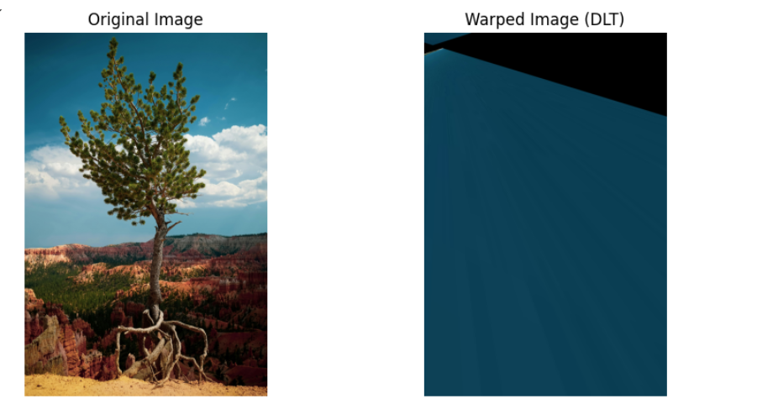

16. Perform Edge detection using canny method.
AIM: To Perform Edge detection using canny method.
PROGRAM:
import cv2
import numpy as np
import matplotlib.pyplot as plt
from PIL import Image

image_path = '/content/pexels-optical-chemist-340351297-31921731.jpg'
image = Image.open(image_path).convert('L')
image_np = np.array(image)

edges = cv2.Canny(image_np, threshold1=100, threshold2=200)

plt.figure(figsize=(10, 5))
plt.subplot(1, 2, 1)
plt.imshow(image_np, cmap='gray')
plt.title('Original Image')
plt.axis('off')

plt.subplot(1, 2, 2)
plt.imshow(edges, cmap='gray')
plt.title('Canny Edge Detection')
plt.axis('off')

plt.show()
INPUT AND OUTPUT:
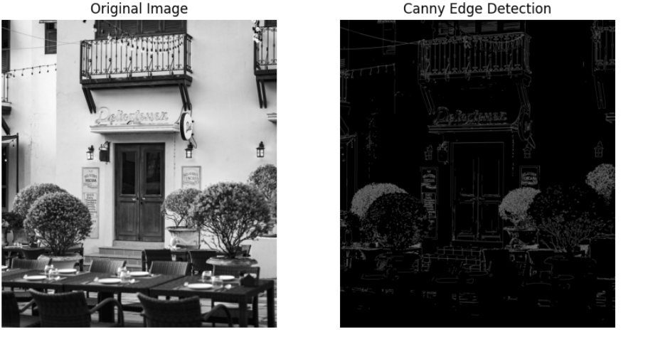
17. Perform Edge detection using Sobel Matrix along X axis.
AIM: To Perform Edge detection using Sobel Matrix along X axis.
PROGRAM:
import cv2
import numpy as np
import matplotlib.pyplot as plt
from PIL import Image

image_path = '/content/pexels-jonaskakaroto-736230.jpg'
image = Image.open(image_path).convert('L')
image_np = np.array(image)

sobel_x = cv2.Sobel(image_np, cv2.CV_64F, 1, 0, ksize=3)
sobel_x = cv2.convertScaleAbs(sobel_x)

plt.figure(figsize=(10, 5))
plt.subplot(1, 2, 1)
plt.imshow(image_np, cmap='gray')
plt.title('Original Image')
plt.axis('off')

plt.subplot(1, 2, 2)
plt.imshow(sobel_x, cmap='gray')
plt.title('Sobel Edge Detection (X-axis)')
plt.axis('off')

plt.show()

INPUT AND OUTPUT:
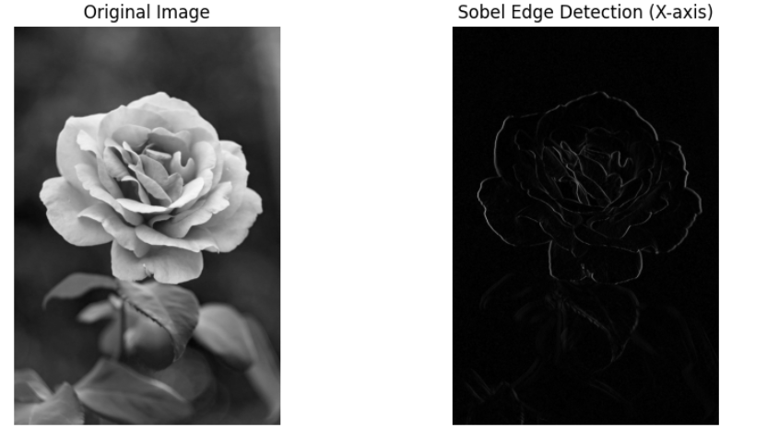

18. Perform Edge detection using Sobel Matrix along Y axis.
AIM: To Perform Edge detection using Sobel Matrix along Y axis
PROGRAM:
import cv2
import numpy as np
import matplotlib.pyplot as plt
from PIL import Image

image_path = '/content/pexels-jonaskakaroto-736230.jpg'
image = Image.open(image_path).convert('L')
image_np = np.array(image)

sobel_y = cv2.Sobel(image_np, cv2.CV_64F, 0, 1, ksize=3)
sobel_y = cv2.convertScaleAbs(sobel_y)

plt.figure(figsize=(10, 5))
plt.subplot(1, 2, 1)
plt.imshow(image_np, cmap='gray')
plt.title('Original Image')
plt.axis('off')

plt.subplot(1, 2, 2)
plt.imshow(sobel_y, cmap='gray')
plt.title('Sobel Edge Detection (Y-axis)')
plt.axis('off')

plt.show()
INPUT AND OUTPUT:
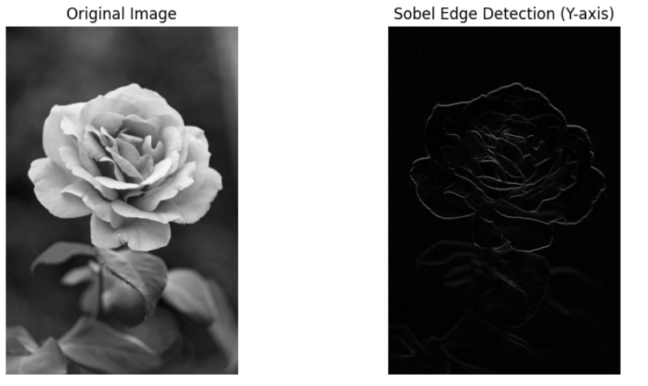

19. Perform Edge detection using Sobel Matrix along XY axis
AIM: To Perform Edge detection using Sobel Matrix along XY axis
PROGRAM:
import cv2
import numpy as np
import matplotlib.pyplot as plt
from PIL import Image

image_path = '/content/Virat kohli wallpaper 📍.jpeg'
image = Image.open(image_path).convert('L')
image_np = np.array(image)

sobel_x = cv2.Sobel(image_np, cv2.CV_64F, 1, 0, ksize=3)
sobel_y = cv2.Sobel(image_np, cv2.CV_64F, 0, 1, ksize=3)

sobel_xy = cv2.magnitude(sobel_x, sobel_y)
sobel_xy = cv2.convertScaleAbs(sobel_xy)

plt.figure(figsize=(10, 5))
plt.subplot(1, 2, 1)
plt.imshow(image_np, cmap='gray')
plt.title('Original Image')
plt.axis('off')

plt.subplot(1, 2, 2)
plt.imshow(sobel_xy, cmap='gray')
plt.title('Sobel Edge Detection (X + Y)')
plt.axis('off')

plt.show()

INPUT AND OUPUT:
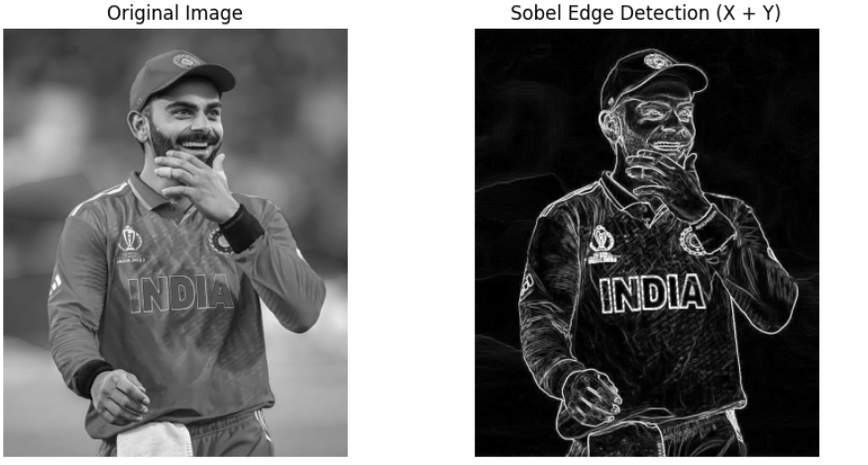

20. Perform Sharpening of Image using Laplacian mask with negative center coefficient.
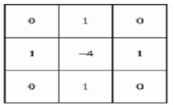
AIM: To Perform Sharpening of Image using Laplacian mask with negative center coefficient.
PROGRAM:
import cv2
import numpy as np
import matplotlib.pyplot as plt

# Load the image
image = cv2.imread('/content/pexels-frans-van-heerden-201846-2375010.jpg', cv2.IMREAD_GRAYSCALE)

# Define Laplacian kernel with a negative center coefficient
laplacian_kernel = np.array([[0, 1, 0],
[1, -4, 1],
[0, 1, 0]])

# Apply the Laplacian filter
laplacian = cv2.filter2D(image, -1, laplacian_kernel)

# Sharpened image = original image - Laplacian
sharpened = cv2.subtract(image, laplacian)

# Display the results
plt.figure(figsize=(12, 6))
plt.subplot(1, 3, 1)
plt.title("Original Image")
plt.imshow(image, cmap='gray')

plt.subplot(1, 3, 2)
plt.title("Laplacian (Edges)")
plt.imshow(laplacian, cmap='gray')

plt.subplot(1, 3, 3)
plt.title("Sharpened Image")
plt.imshow(sharpened, cmap='gray')

plt.tight_layout()
plt.show()
INPIUT AND OUPUT:
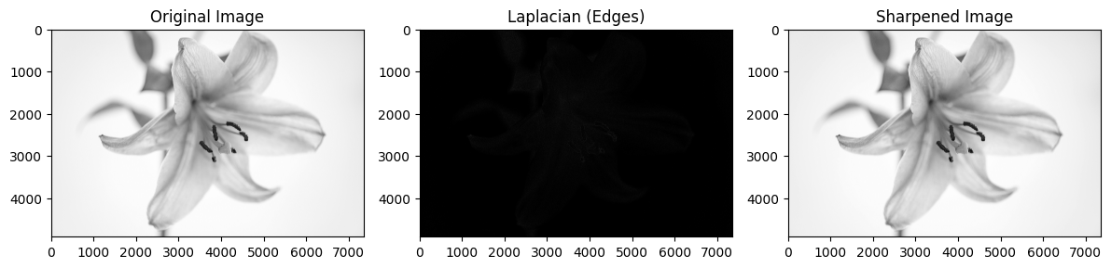

21. Perform Sharpening of Image using Laplacian mask implemented with an extension of
diagonal neighbors,
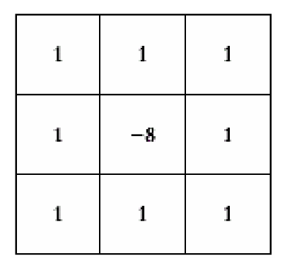
AIM: To Perform Sharpening of Image using Laplacian mask implemented with an extension of diagonal neighbors.
PROGRAM:
import cv2
import numpy as np
import matplotlib.pyplot as plt

# Load the image (grayscale)
image = cv2.imread('/content/pexels-souvenirpixels-1519088.jpg', cv2.IMREAD_GRAYSCALE)

# Define Laplacian kernel including diagonal neighbors
laplacian_kernel = np.array([[1, 1, 1],
[1, -8, 1],
[1, 1, 1]])

# Apply the Laplacian filter
laplacian = cv2.filter2D(image, -1, laplacian_kernel)

# Sharpen the image by subtracting the Laplacian result
sharpened = cv2.subtract(image, laplacian)

# Clip to avoid negative or >255 values (in case you're doing more complex processing)
sharpened = np.clip(sharpened, 0, 255).astype(np.uint8)

# Display the results
plt.figure(figsize=(12, 6))

plt.subplot(1, 3, 1)
plt.title("Original Image")
plt.imshow(image, cmap='gray')

plt.subplot(1, 3, 2)
plt.title("Laplacian (All Neighbors)")
plt.imshow(laplacian, cmap='gray')

plt.subplot(1, 3, 3)
plt.title("Sharpened Image")
plt.imshow(sharpened, cmap='gray')

plt.tight_layout()
plt.show()
INPUT AND OUTPUT:

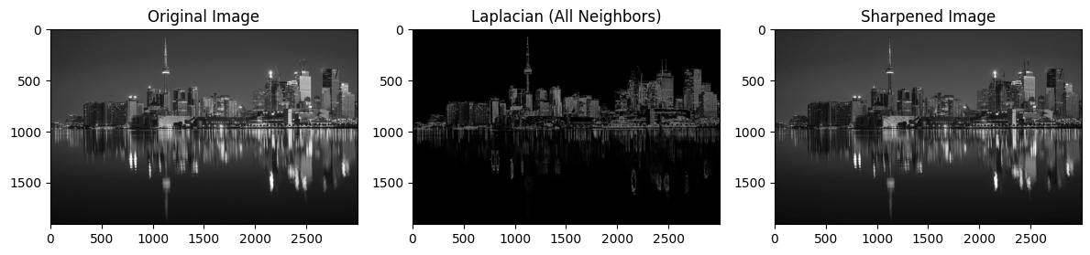
22. Perform Sharpening of Image using Laplacian mask with positive center coefficient.
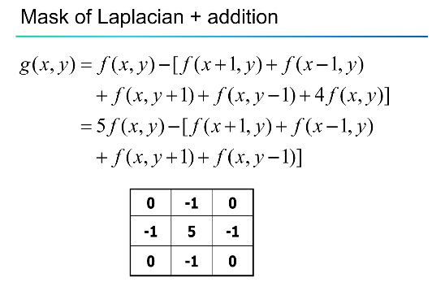
AIM: To Perform Sharpening of Image using Laplacian mask with positive center coefficient.
PROGRAM:
import cv2
import numpy as np
import matplotlib.pyplot as plt

# Load the image in grayscale
image = cv2.imread('/content/pexels-jriika-1704899.jpg', cv2.IMREAD_GRAYSCALE)

# Define Laplacian kernel with positive center
laplacian_kernel = np.array([[-1, -1, -1],
[-1, 8, -1],
[-1, -1, -1]])

# Apply the Laplacian kernel
laplacian = cv2.filter2D(image, -1, laplacian_kernel)

# Sharpened image: add the Laplacian to the original
sharpened = cv2.add(image, laplacian)

# Clip to valid range
sharpened = np.clip(sharpened, 0, 255).astype(np.uint8)

# Display the results
plt.figure(figsize=(12, 6))

plt.subplot(1, 3, 1)
plt.title("Original Image")
plt.imshow(image, cmap='gray')

plt.subplot(1, 3, 2)
plt.title("Laplacian (Positive Center)")
plt.imshow(laplacian, cmap='gray')

plt.subplot(1, 3, 3)
plt.title("Sharpened Image")
plt.imshow(sharpened, cmap='gray')

plt.tight_layout()
plt.show()

INPUT AMD OUTPUT:

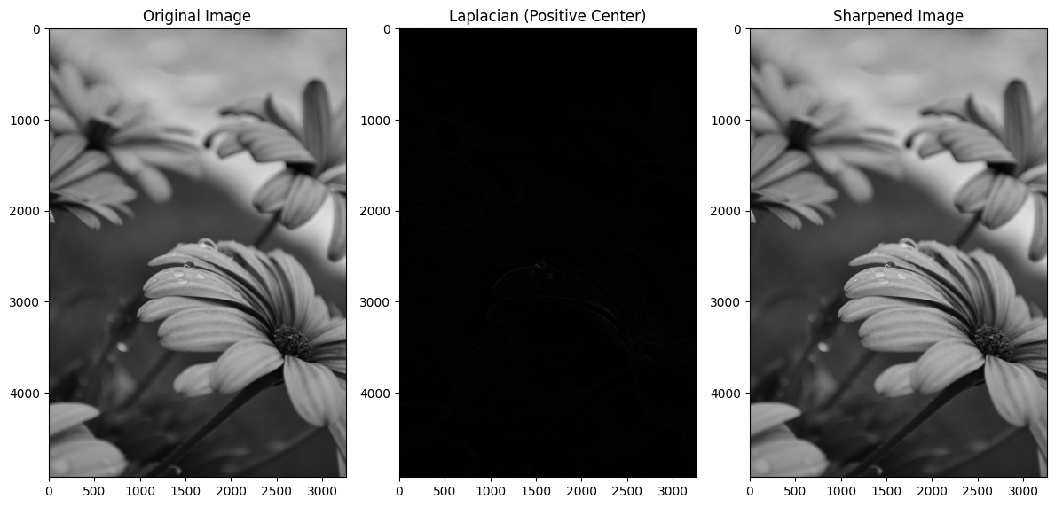

23. Perform Sharpening of Image using unsharp masking.
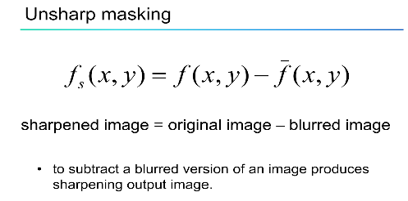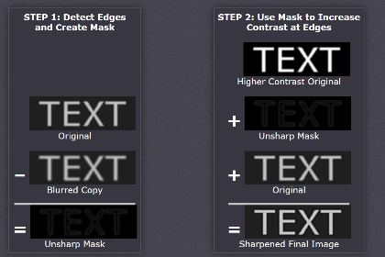
AIM: To Perform Sharpening of Image using unsharp masking.
PROGRAM:
import cv2
import numpy as np
import matplotlib.pyplot as plt

# Load the image in grayscale
image = cv2.imread('/content/pexels-souvenirpixels-1519088.jpg', cv2.IMREAD_GRAYSCALE)

# Apply Gaussian blur to get the "unsharp" image
blurred = cv2.GaussianBlur(image, (5, 5), sigmaX=1.0)

# Create the unsharp mask
mask = cv2.subtract(image, blurred)

# Set sharpening amount
amount = 1.5

# Add mask to the original image to get the sharpened image
sharpened = cv2.addWeighted(image, 1 + amount, blurred, -amount, 0)

# Clip to valid range
sharpened = np.clip(sharpened, 0, 255).astype(np.uint8)

# Display results
plt.figure(figsize=(12, 6))

plt.subplot(1, 3, 1)
plt.title("Original Image")
plt.imshow(image, cmap='gray')

plt.subplot(1, 3, 2)
plt.title("Blurred Image")
plt.imshow(blurred, cmap='gray')

plt.subplot(1, 3, 3)
plt.title("Sharpened (Unsharp Masking)")
plt.imshow(sharpened, cmap='gray')

plt.tight_layout()
plt.show()

INPUT AND OUPUT:
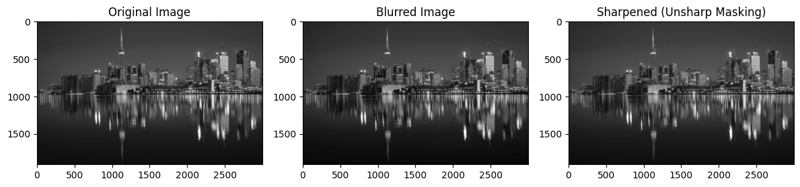

24. Perform Sharpening of Image using High-Boost Masks.
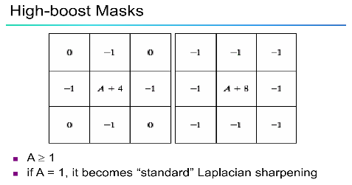
AIM: To Perform Sharpening of Image using High-Boost Masks.
PROGRAM:
mport cv2
import numpy as np
import matplotlib.pyplot as plt

# Load image in grayscale
image = cv2.imread('/content/pexels-pixabay-36729.jpg', cv2.IMREAD_GRAYSCALE)

# Blur the image (low-pass filter)
blurred = cv2.GaussianBlur(image, (5, 5), sigmaX=1.0)

# Set high-boost scaling factor (A > 1)
A = 1.5

# Apply high-boost filter
high_boost = cv2.addWeighted(image, A, blurred, -(A - 1), 0)

# Clip the result
high_boost = np.clip(high_boost, 0, 255).astype(np.uint8)

# Display results
plt.figure(figsize=(12, 6))

plt.subplot(1, 3, 1)
plt.title("Original Image")
plt.imshow(image, cmap='gray')

plt.subplot(1, 3, 2)
plt.title("Blurred Image")
plt.imshow(blurred, cmap='gray')

plt.subplot(1, 3, 3)
plt.title(f"High-Boost Sharpened (A={A})")
plt.imshow(high_boost, cmap='gray')

plt.tight_layout()
plt.show()
INPUT AND OUTPUT:
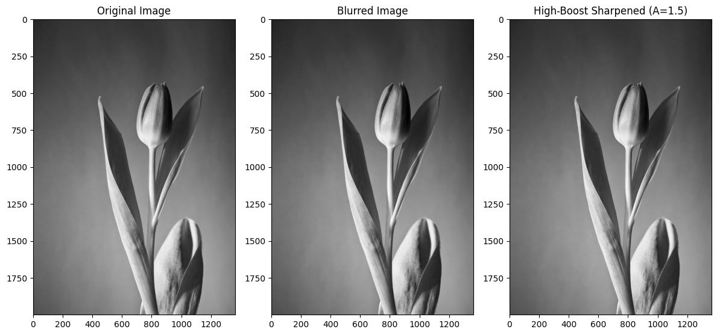
25. Perform Sharpening of Image using Gradient masking.
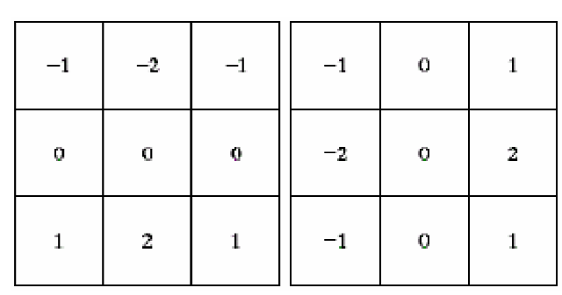
AIM: To Perform Sharpening of Image using Gradient masking.
PROGRAM:
import cv2
import numpy as np
import matplotlib.pyplot as plt

# Load the image in grayscale
image = cv2.imread('/content/pexels-frans-van-heerden-201846-2375010.jpg', cv2.IMREAD_GRAYSCALE)

# Compute gradients using Sobel operator
grad_x = cv2.Sobel(image, cv2.CV_64F, 1, 0, ksize=3)
grad_y = cv2.Sobel(image, cv2.CV_64F, 0, 1, ksize=3)

# Compute gradient magnitude
gradient_magnitude = np.sqrt(grad_x**2 + grad_y**2)
gradient_magnitude = np.clip(gradient_magnitude, 0, 255).astype(np.uint8)

# Sharpen the image by adding gradient
alpha = 1.0 # controls sharpening strength
sharpened = cv2.addWeighted(image, 1.0, gradient_magnitude, alpha, 0)
sharpened = np.clip(sharpened, 0, 255).astype(np.uint8)

# Display the images
plt.figure(figsize=(12, 6))

plt.subplot(1, 3, 1)
plt.title("Original Image")
plt.imshow(image, cmap='gray')

plt.subplot(1, 3, 2)
plt.title("Gradient Magnitude")
plt.imshow(gradient_magnitude, cmap='gray')

plt.subplot(1, 3, 3)
plt.title("Sharpened Image (Gradient Mask)")
plt.imshow(sharpened, cmap='gray')

plt.tight_layout()
plt.show()
INPUT AND OUTPUT:

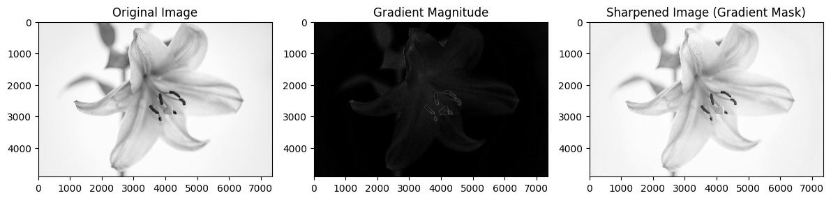
26. Insert water marking to the image using OpenCV.
AIM: To Insert water marking to the image using OpenCV.
PROGRAM:
# Step 1: Install OpenCV if not already installed
!pip install opencv-python-headless

# Step 2: Upload an image file
from google.colab import files
uploaded = files.upload()

import cv2
import numpy as np
from matplotlib import pyplot as plt
from PIL import Image
import io

# Step 3: Load the uploaded image
image_path = next(iter(uploaded)) # gets the first uploaded file
image = cv2.imread(image_path)
image = cv2.cvtColor(image, cv2.COLOR_BGR2RGB) # convert BGR to RGB

# Step 4: Define watermark text and parameters
watermark_text = "Watermark"
font = cv2.FONT_HERSHEY_SIMPLEX
font_scale = 1
color = (255, 255, 255) # white color
thickness = 2
position = (10, image.shape[0] - 10) # bottom-left corner

# Step 5: Add watermark to the image
watermarked_image = image.copy()
cv2.putText(watermarked_image, watermark_text, position, font, font_scale, color, thickness, cv2.LINE_AA)

# Step 6: Display original and watermarked images
plt.figure(figsize=(10, 5))
plt.subplot(1, 2, 1)
plt.imshow(image)
plt.title("Original Image")
plt.axis("off")

plt.subplot(1, 2, 2)
plt.imshow(watermarked_image)
plt.title("Watermarked Image")
plt.axis("off")
plt.show()

INPUT AND OUTPUT:
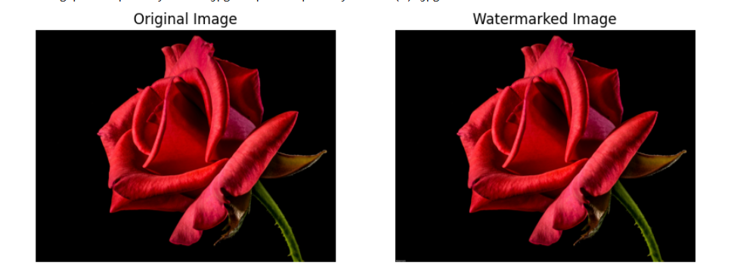
27. Do Cropping, Copying and pasting image inside another image using OpenCV.
AIM: To Do Cropping, Copying and pasting image inside another image using OpenCV.
PROGRAM:
Step 1: Install OpenCV (usually pre-installed in Colab)
!pip install opencv-python-headless

# Step 2: Import libraries
import cv2
from google.colab import files
import numpy as np
from matplotlib import pyplot as plt

# Step 3: Upload images
print("Upload the base image (where you want to paste):")
base_uploaded = files.upload()

print("Upload the source image (from which to crop):")
source_uploaded = files.upload()

# Step 4: Read the images
base_image_path = next(iter(base_uploaded))
source_image_path = next(iter(source_uploaded))

base_img = cv2.imread(base_image_path)
source_img = cv2.imread(source_image_path)

# Optional: Resize for simplicity
base_img = cv2.resize(base_img, (600, 400))
source_img = cv2.resize(source_img, (300, 200))

# Step 5: Crop a region from the source image
# (y1:y2, x1:x2)
crop = source_img[50:150, 50:250]

# Step 6: Paste the cropped region onto the base image at a desired location
# E.g., top-left corner (100, 100)
y, x = 100, 100
h, w, _ = crop.shape
base_img[y:y+h, x:x+w] = crop

# Step 7: Display the result
plt.imshow(cv2.cvtColor(base_img, cv2.COLOR_BGR2RGB))
plt.title("Result Image")
plt.axis('off')
plt.show()

# Step 8: Save the result
cv2.imwrite("result_image.jpg", base_img)
print("Saved as result_image.jpg")
INPUT AND OUTPUT:
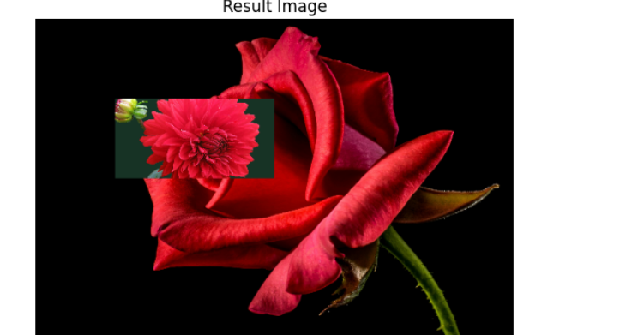

28. Find the boundary of the image using Convolution kernel for the given image.
AIM: To Find the boundary of the image using Convolution kernel for the given image.
PROGRAM:
# Step 1: Install OpenCV (if not installed)
!pip install opencv-python-headless

# Step 2: Import libraries
import cv2
import numpy as np
from matplotlib import pyplot as plt
from google.colab import files

# Step 3: Upload the image
print("/content/pexels-pixabay-60597.jpg")
uploaded = files.upload()
image_path = next(iter(uploaded))

# Step 4: Read and convert to grayscale
img = cv2.imread(image_path)
gray = cv2.cvtColor(img, cv2.COLOR_BGR2GRAY)

# Step 5: Define Prewitt kernels for x and y directions
kernelx = np.array([[1, 0, -1],
[1, 0, -1],
[1, 0, -1]])

kernely = np.array([[1, 1, 1],
[0, 0, 0],
[-1, -1, -1]])

# Step 6: Apply convolution using filter2D
edge_x = cv2.filter2D(gray, -1, kernelx)
edge_y = cv2.filter2D(gray, -1, kernely)

# Combine the two directions
edges = cv2.addWeighted(edge_x, 0.5, edge_y, 0.5, 0)

# Step 7: Display the result
plt.figure(figsize=(12, 5))
plt.subplot(1, 2, 1)
plt.imshow(gray, cmap='gray')
plt.title("Original Grayscale")

plt.subplot(1, 2, 2)
plt.imshow(edges, cmap='gray')
plt.title("Edge Detected (Prewitt)")

plt.show()

# Step 8: Save the result
cv2.imwrite("edge_detected.jpg", edges)
print("Saved as edge_detected.jpg")
INPUT AND OUTPUT:
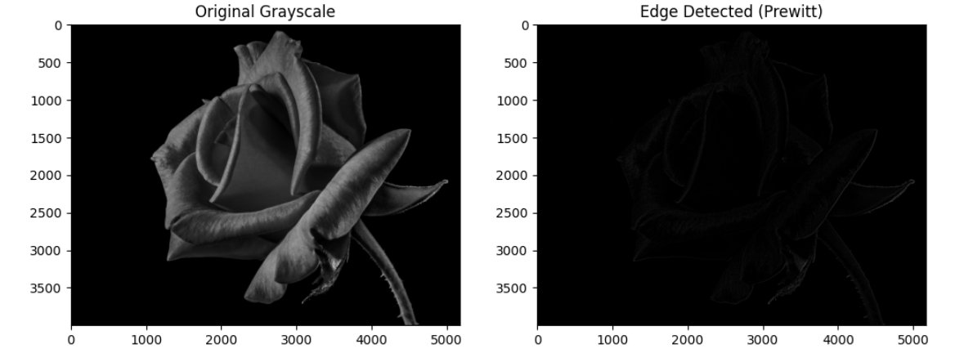

29. Morphological operations based on OpenCV using Erosion technique.
AIM: To Morphological operations based on OpenCV using Erosion technique.
PROGRAM:
# Step 1: Install OpenCV (if not already)
!pip install opencv-python-headless

# Step 2: Import libraries
import cv2
import numpy as np
from matplotlib import pyplot as plt
from google.colab import files

# Step 3: Upload an image
print("Upload a binary or grayscale image:")
uploaded = files.upload()
image_path = next(iter(uploaded))

# Step 4: Read the image
img = cv2.imread(image_path, cv2.IMREAD_GRAYSCALE)

# Step 5: Threshold (if needed) to make binary
# Convert grayscale to binary (0 or 255)
_, binary = cv2.threshold(img, 127, 255, cv2.THRESH_BINARY)

# Step 6: Define kernel (structuring element)
kernel = np.ones((5, 5), np.uint8) # 5x5 square kernel

# Step 7: Apply erosion
eroded = cv2.erode(binary, kernel, iterations=1)

# Step 8: Show results
plt.figure(figsize=(10, 5))
plt.subplot(1, 2, 1)
plt.imshow(binary, cmap='gray')
plt.title('Original Binary Image')
plt.axis('off')

plt.subplot(1, 2, 2)
plt.imshow(eroded, cmap='gray')
plt.title('Eroded Image')
plt.axis('off')

plt.show()

# Step 9: Save the output
cv2.imwrite("eroded_output.jpg", eroded)
print("Saved as eroded_output.jpg")
INPUT AND OUPUT:

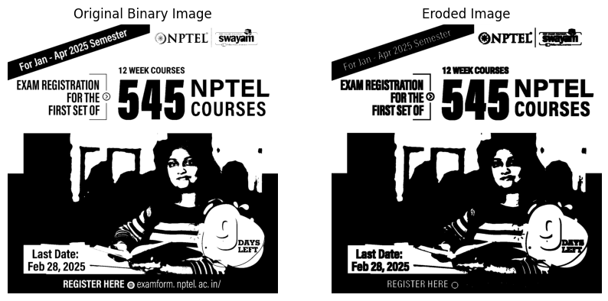
30. Morphological operations based on OpenCV using Dilation technique.
AIM: To Morphological operations based on OpenCV using Dilation technique.
PROGRAM: # Step 1: Install OpenCV (if not already installed)
!pip install opencv-python-headless

# Step 2: Import required libraries
import cv2
import numpy as np
from matplotlib import pyplot as plt
from google.colab import files

# Step 3: Upload an image
print("Upload a binary or grayscale image:")
uploaded = files.upload()
image_path = next(iter(uploaded))

# Step 4: Read the image in grayscale
img = cv2.imread(image_path, cv2.IMREAD_GRAYSCALE)

# Step 5: Convert to binary (thresholding)
_, binary = cv2.threshold(img, 127, 255, cv2.THRESH_BINARY)

# Step 6: Define the structuring element (kernel)
kernel = np.ones((5, 5), np.uint8) # Square 5x5 kernel

# Step 7: Apply dilation
dilated = cv2.dilate(binary, kernel, iterations=1)

# Step 8: Display the original and dilated images
plt.figure(figsize=(10, 5))

plt.subplot(1, 2, 1)
plt.imshow(binary, cmap='gray')
plt.title('Original Binary Image')
plt.axis('off')

plt.subplot(1, 2, 2)
plt.imshow(dilated, cmap='gray')
plt.title('Dilated Image')
plt.axis('off')

plt.show()

# Step 9: Save the dilated image
cv2.imwrite("dilated_output.jpg", dilated)
print("Saved as dilated_output.jpg")

INPUT AND OUTPUT:

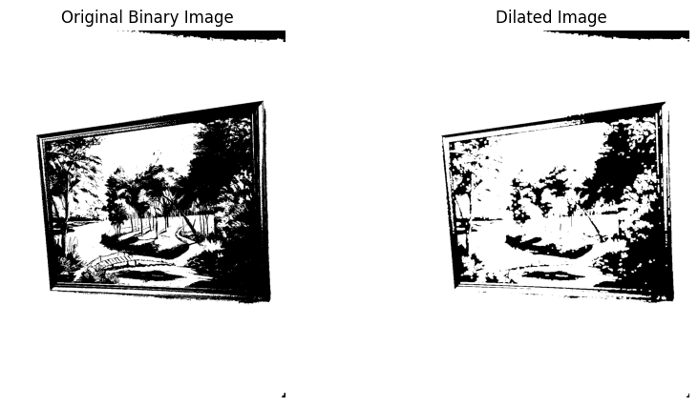
31. Morphological operations based on OpenCV using Opening technique.
Aim: To Morphological operations based on OpenCV using Opening technique.
PROGRAM:

# Step 1: Install OpenCV (if needed)
!pip install opencv-python-headless

# Step 2: Import necessary libraries
import cv2
import numpy as np
from matplotlib import pyplot as plt
from google.colab import files

# Step 3: Upload an image
print("Upload a binary or grayscale image:")
uploaded = files.upload()
image_path = next(iter(uploaded))

# Step 4: Read the image in grayscale
img = cv2.imread(image_path, cv2.IMREAD_GRAYSCALE)

# Step 5: Convert to binary image using thresholding
_, binary = cv2.threshold(img, 127, 255, cv2.THRESH_BINARY)

# Step 6: Define the structuring element (kernel)
kernel = np.ones((5, 5), np.uint8) # You can adjust the size

# Step 7: Apply Opening (Erosion followed by Dilation)
opened = cv2.morphologyEx(binary, cv2.MORPH_OPEN, kernel)

# Step 8: Display the original and opened images
plt.figure(figsize=(10, 5))

plt.subplot(1, 2, 1)
plt.imshow(binary, cmap='gray')
plt.title('Original Binary Image')
plt.axis('off')

plt.subplot(1, 2, 2)
plt.imshow(opened, cmap='gray')
plt.title('After Opening')
plt.axis('off')

plt.show()

# Step 9: Save the opened image
cv2.imwrite("opened_output.jpg", opened)
print("Saved as opened_output.jpg")
INPUT AND OUTPUT:

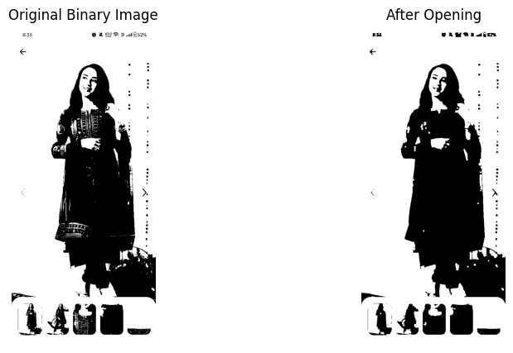
32. Morphological operations based on OpenCV using Closing technique.
AIM: To Morphological operations based on OpenCV using Closing technique.
PROGRAM:
# Step 1: Install OpenCV (if not already)
!pip install opencv-python-headless

# Step 2: Import necessary libraries
import cv2
import numpy as np
from matplotlib import pyplot as plt
from google.colab import files

# Step 3: Upload an image
print("Upload a binary or grayscale image:")
uploaded = files.upload()
image_path = next(iter(uploaded))

# Step 4: Read image in grayscale
img = cv2.imread(image_path, cv2.IMREAD_GRAYSCALE)

# Step 5: Convert to binary image using thresholding
_, binary = cv2.threshold(img, 127, 255, cv2.THRESH_BINARY)

# Step 6: Define the structuring element (kernel)
kernel = np.ones((5, 5), np.uint8)

# Step 7: Apply Closing (Dilation followed by Erosion)
closed = cv2.morphologyEx(binary, cv2.MORPH_CLOSE, kernel)

# Step 8: Display original and closed image
plt.figure(figsize=(10, 5))

plt.subplot(1, 2, 1)
plt.imshow(binary, cmap='gray')
plt.title('Original Binary Image')
plt.axis('off')
plt.subplot(1, 2, 2)
plt.imshow(closed, cmap='gray')
plt.title('After Closing')
plt.axis('off')
plt.show()

# Step 9: Save the result
cv2.imwrite("closed_output.jpg", closed)
print("Saved as closed_output.jpg")

INPUT AND OUTPUT:
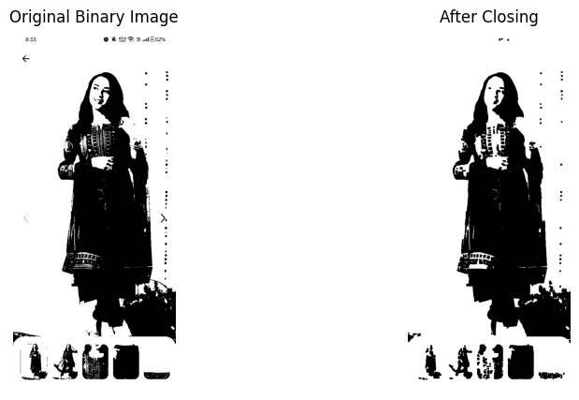

33. Morphological operations based on OpenCV using Morphological Gradient technique.
AIM: To Morphological operations based on OpenCV using Morphological Gradient technique.
PROGRAM:
# Step 1: Install OpenCV
!pip install opencv-python-headless

# Step 2: Import required libraries
import cv2
import numpy as np
from matplotlib import pyplot as plt
from google.colab import files

# Step 3: Upload a binary or grayscale image
print("Upload a binary or grayscale image:")
uploaded = files.upload()
image_path = next(iter(uploaded))

# Step 4: Read the image
img = cv2.imread(image_path, cv2.IMREAD_GRAYSCALE)

# Step 5: Threshold to ensure binary format (optional for clean input)
_, binary = cv2.threshold(img, 127, 255, cv2.THRESH_BINARY)

# Step 6: Define kernel
kernel = np.ones((5, 5), np.uint8)

# Step 7: Apply Morphological Gradient
gradient = cv2.morphologyEx(binary, cv2.MORPH_GRADIENT, kernel)

# Step 8: Show original and gradient images
plt.figure(figsize=(10, 5))

plt.subplot(1, 2, 1)
plt.imshow(binary, cmap='gray')
plt.title('Original Binary Image')
plt.axis('off')

plt.subplot(1, 2, 2)
plt.imshow(gradient, cmap='gray')
plt.title('Morphological Gradient')
plt.axis('off')

plt.show()

# Step 9: Save the result
cv2.imwrite("gradient_output.jpg", gradient)
print("Saved as gradient_output.jpg")

INPUT NAD OUTPUT:
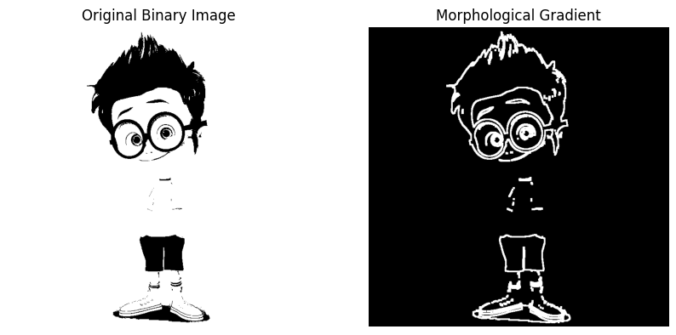
34. Morphological operations based on OpenCV using Top hat technique.
AIM: To Morphological operations based on OpenCV using Top hat technique.

PROGRAM:

# Step 1: Install OpenCV
!pip install opencv-python-headless

# Step 2: Import necessary libraries
import cv2
import numpy as np
from matplotlib import pyplot as plt
from google.colab import files

# Step 3: Upload an image
print("Upload a grayscale image:")
uploaded = files.upload()
image_path = next(iter(uploaded))

# Step 4: Read image in grayscale
img = cv2.imread(image_path, cv2.IMREAD_GRAYSCALE)

# Step 5: Define kernel (structuring element)
kernel = np.ones((15, 15), np.uint8) # Larger kernel enhances effect

# Step 6: Apply Top-Hat transformation
tophat = cv2.morphologyEx(img, cv2.MORPH_TOPHAT, kernel)

# Step 7: Display results
plt.figure(figsize=(10, 5))

plt.subplot(1, 2, 1)
plt.imshow(img, cmap='gray')
plt.title('Original Image')
plt.axis('off')

plt.subplot(1, 2, 2)
plt.imshow(tophat, cmap='gray')
plt.title('Top-Hat Result')
plt.axis('off')

plt.show()

# Step 8: Save the result
cv2.imwrite("tophat_output.jpg", tophat)
print("Saved as tophat_output.jpg")

INPUT AND OUTPUT:
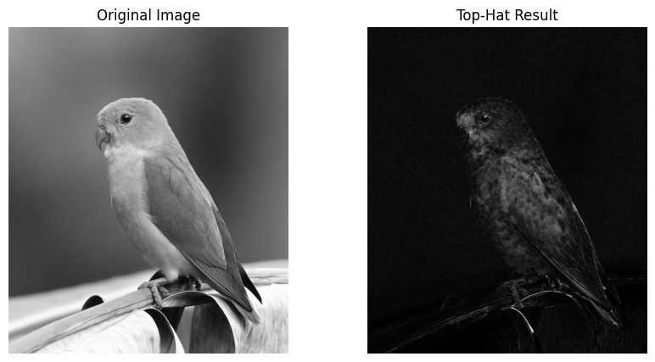
35. Morphological operations based on OpenCV using Black hat technique.
AIM: To Morphological operations based on OpenCV using Top hat technique.

PROGRAM:
# Step 1: Install OpenCV
!pip install opencv-python-headless

# Step 2: Import required libraries
import cv2
import numpy as np
from matplotlib import pyplot as plt
from google.colab import files

# Step 3: Upload an image
print("Upload a grayscale image:")
uploaded = files.upload()
image_path = next(iter(uploaded))

# Step 4: Read the image in grayscale
img = cv2.imread(image_path, cv2.IMREAD_GRAYSCALE)

# Step 5: Define the structuring element (kernel)
kernel = np.ones((15, 15), np.uint8)

# Step 6: Apply Black-Hat transformation
blackhat = cv2.morphologyEx(img, cv2.MORPH_BLACKHAT, kernel)

# Step 7: Display the results
plt.figure(figsize=(10, 5))

plt.subplot(1, 2, 1)
plt.imshow(img, cmap='gray')
plt.title('Original Image')
plt.axis('off')

plt.subplot(1, 2, 2)
plt.imshow(blackhat, cmap='gray')
plt.title('Black-Hat Result')
plt.axis('off')

plt.show()

# Step 8: Save the result
cv2.imwrite("blackhat_output.jpg", blackhat)
print("Saved as blackhat_output.jpg")

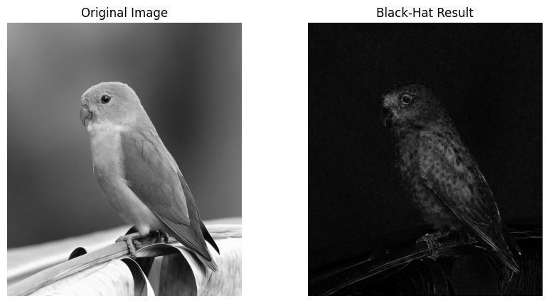
36. Recognise watch from the given image by general Object recognition using OpenCV.
AIM: To recognise watch from the given image by general Object recognition using OpenCV.
PROGRAM:
# STEP 1: Install YOLO
!pip install ultralytics

# STEP 2: Upload Image
from google.colab import files
uploaded = files.upload()
filename = next(iter(uploaded))

# STEP 3: Load YOLO Model and Run Detection
from ultralytics import YOLO
from PIL import Image
import matplotlib.pyplot as plt

model = YOLO("yolov8n.pt") # Small & fast model

# Load and detect
img = Image.open(filename)
results = model(img)

# STEP 4: Show Image with Detections
results[0].show()

# STEP 5: Optional - Print Detected Classes
print("Detected objects:")
for box in results[0].boxes:
cls_id = int(box.cls[0])
name = model.names[cls_id]
print("-", name)
INPUT AND OUTPUT:
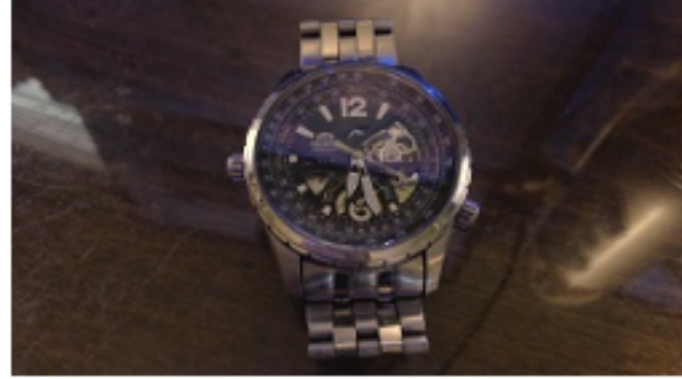

37. Using Opencv play Video in Reverse mode.
AIM: To use Opencv to play theVideo in Reverse mode.
PROGRAM:
import cv2

# Path to your video file
video_path = 'your_video.mp4' # Replace with your video path

# Open the video
cap = cv2.VideoCapture(video_path)

# Get total number of frames
frame_count = int(cap.get(cv2.CAP_PROP_FRAME_COUNT))

# Get frame rate
fps = cap.get(cv2.CAP_PROP_FPS)

# Get video frame dimensions
width = int(cap.get(cv2.CAP_PROP_FRAME_WIDTH))
height = int(cap.get(cv2.CAP_PROP_FRAME_HEIGHT))

# Create a window
cv2.namedWindow("Reverse Video", cv2.WINDOW_NORMAL)

# Loop over the frames in reverse order
for i in range(frame_count - 1, -1, -1):
cap.set(cv2.CAP_PROP_POS_FRAMES, i)
ret, frame = cap.read()
if not ret:
continue
frame = cv2.resize(frame, (width, height))
cv2.imshow('Reverse Video', frame)

# Press ESC to break
if cv2.waitKey(int(1000 / fps)) & 0xFF == 27:
break

# Release everything
cap.release()
cv2.destroyAllWindows()
INPUT AND OUPUT:
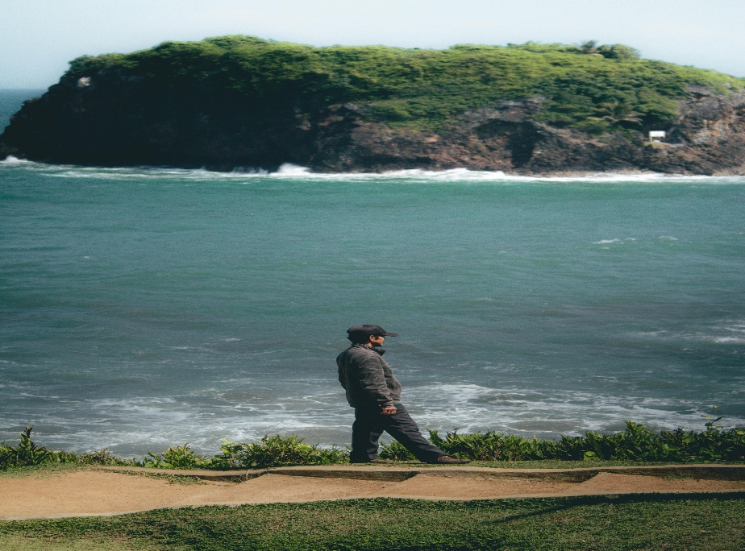

38. Face Detection using Opencv.
AIM: To Detect Face using Opencv.
PROGRAM:
import cv2
from google.colab.patches import cv2_imshow
from google.colab import files
import numpy as np

# Upload the image
uploaded = files.upload()
file_name = next(iter(uploaded))

# Load Haar cascade for face detection
face_cascade = cv2.CascadeClassifier(cv2.data.haarcascades + 'haarcascade_frontalface_default.xml')

# Read the original image
original = cv2.imread(file_name)

# Convert to grayscale for face detection
gray = cv2.cvtColor(original, cv2.COLOR_BGR2GRAY)

# Detect faces
faces = face_cascade.detectMultiScale(gray, scaleFactor=1.1, minNeighbors=5)

# Make a copy of original image to draw rectangles on
output = original.copy()

# Draw rectangles around faces
for (x, y, w, h) in faces:
cv2.rectangle(output, (x, y), (x + w, y + h), (0, 255, 0), 2)

# Resize images if needed (optional, to ensure same height)
# Here we assume images are same size as original and output are same size

# Stack images side by side (horizontal stack)
combined = np.hstack((original, output))

# Display the combined image
cv2_imshow(combined)

INPUT AND OUTPUT:
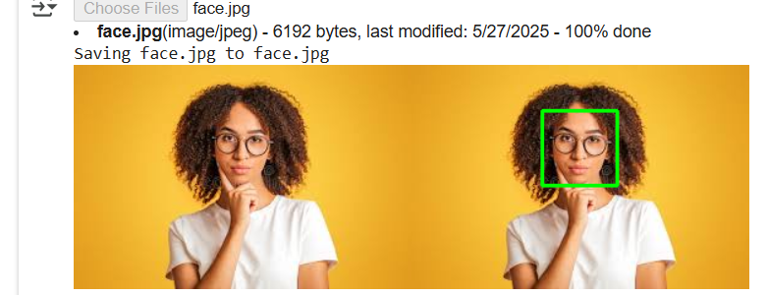
39. Vehicle Detection in a Video frame using OpenCV .
AIM: To Vehicle Detection in a Video frame using OpenCV .
PROGRAM:
pip install opencv-python
import cv2

# Load video
video_path = 'traffic_video.mp4' # Replace with your video path
cap = cv2.VideoCapture(video_path)

# Create background subtractor
fgbg = cv2.createBackgroundSubtractorMOG2(history=100, varThreshold=40)

# Define kernel for morphological operations
kernel = cv2.getStructuringElement(cv2.MORPH_RECT, (5, 5))

while cap.isOpened():
ret, frame = cap.read()
if not ret:
break

# Resize frame for consistency
frame = cv2.resize(frame, (800, 450))

# Apply background subtraction
fgmask = fgbg.apply(frame)
fgmask = cv2.morphologyEx(fgmask, cv2.MORPH_OPEN, kernel)

# Find contours in the mask
contours, _ = cv2.findContours(fgmask, cv2.RETR_EXTERNAL, cv2.CHAIN_APPROX_SIMPLE)

for cnt in contours:
# Filter small contours
if cv2.contourArea(cnt) < 500:
continue
x, y, w, h = cv2.boundingRect(cnt)
cv2.rectangle(frame, (x, y), (x + w, y + h), (0, 255, 0), 2)
cv2.putText(frame, 'Vehicle', (x, y - 10), cv2.FONT_HERSHEY_SIMPLEX, 0.9, (36,255,12), 2)

# Show result
cv2.imshow('Vehicle Detection', frame)
if cv2.waitKey(30) & 0xFF == 27: # Press ESC to exit
break

cap.release()
cv2.destroyAllWindows()
INPUT AND OUTPUT:
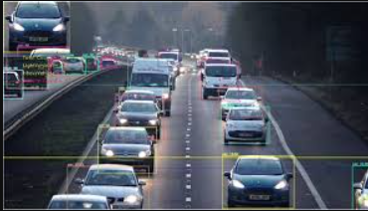

40. Draw Rectangular shape and extract objects.
AIM: To Draw Rectangular shape and extract objects.
PROGRAM:
from PIL import Image
import numpy as np
import cv2
from google.colab.patches import cv2_imshow
from google.colab import files
import os

# Upload file
uploaded = files.upload()
file_name = next(iter(uploaded))

print("Uploaded file:", file_name)

# Rename file to avoid spaces in filename
new_name = file_name.replace(" ", "_")
if new_name != file_name:
os.rename(file_name, new_name)
print(f"Renamed '{file_name}' to '{new_name}'")
else:
new_name = file_name

# Load image with Pillow
pil_img = Image.open(new_name)

# Convert PIL image to OpenCV format
image = cv2.cvtColor(np.array(pil_img), cv2.COLOR_RGB2BGR)

# Convert to grayscale
gray = cv2.cvtColor(image, cv2.COLOR_BGR2GRAY)

# Load Haar cascade
face_cascade = cv2.CascadeClassifier(cv2.data.haarcascades + 'haarcascade_frontalface_default.xml')

# Detect faces
faces = face_cascade.detectMultiScale(gray, scaleFactor=1.1, minNeighbors=5)

print(f"Detected {len(faces)} faces.\n")

# Draw rectangles and extract faces
output_folder = 'extracted_faces'
os.makedirs(output_folder, exist_ok=True)

for i, (x, y, w, h) in enumerate(faces, start=1):
cv2.rectangle(image, (x, y), (x + w, y + h), (0, 255, 0), 2)
face_crop = image[y:y+h, x:x+w]
face_filename = os.path.join(output_folder, f'face_{i}.jpg')
cv2.imwrite(face_filename, face_crop)
print(f"Extracted face {i} saved as: {face_filename}")
cv2_imshow(face_crop)

print("Original image with detected faces:")
cv2_imshow(image)

INPUT :
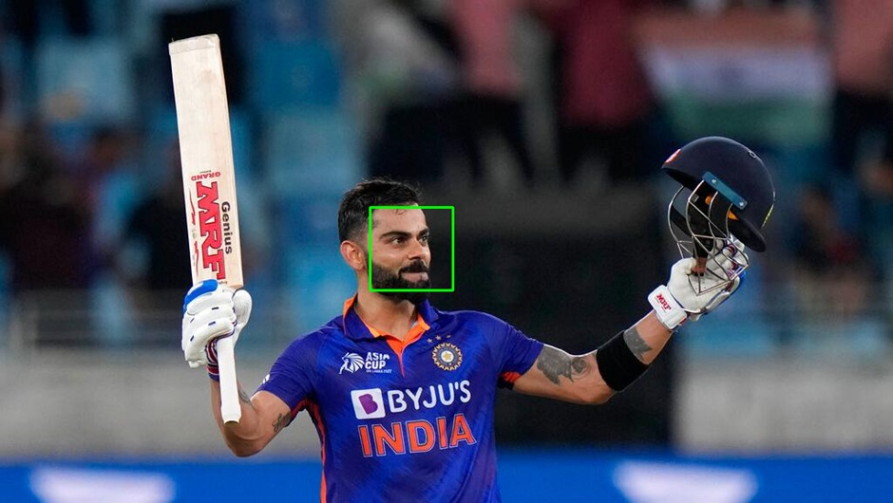

OUTPUT:
